# PeopleSafe - Plan Summary Screen Field Descriptions (Accumulations, Override and Specialty)

Plan Summary Screen

Accumulations Summary

Specialty Summary

Override Summary

Related Documents

**Description:** Field descriptions and information related to the Plan Summary, Accumulations, Specialty and Override Summary screens for RxClaim members.

|  |
| --- |
| Plan Summary Screen |

This screen is used to clarify the plan or explain how and why a claim paid or rejected. It displays general information about a member’s retail/mail order plan benefits such as copays, day supply, accumulations required, etcetera. Although the fields are identical, the information in each field may change according to plan specifications.

 Review the Settlement Codes and Comments of an adjudication and/or Test Claim (ACCEPT or REJECTED) that may explain a critical change to plan parameters before accessing the PBAs (Plan Benefit Attribute); it may be possible to identify a problem from these screens.

The Plan Summary Screen is divided into three sections.

* Section 1: Contains plan information and PBA navigation drop down menus
* Section 2: Displays PBAs selected in the navigation drop down menus
* Section 3: Contains detailed information about the displayed PBAs

**Notes:**

* 99 or 999 in a field acts as a default for unlimited. Review other related fields for additional limitations that may be applicable and negate the unlimited parameter.
* When using the RxClaim system for adjudication, the processed claims is reviewed against what has been filled through both Retail and Mail. The next refill will be based on the Utilization Rate. The Utilization Rate is based on the last location where the same medication was purchased. This information displays on the Plan Summary screen.

**Example:** A retail fill delays a mail order fill until the Retail Utilization rate has passed.

**To view details** for a section, click the “**Show**” link next to the desired section.

**Examples:**

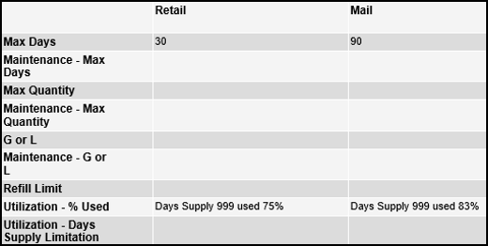

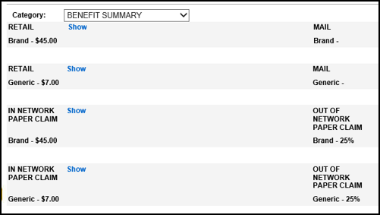

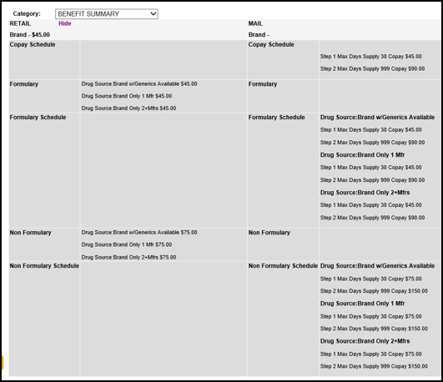

**Note:** For brand drugs, PeopleSafe displays the copay information for all three drug sources:

* M = Multi, Brand only, 2+ Manufacturers
* N = Single, Brand only, 1 Manufacturer
* = Original = Brand w/ Generics Available

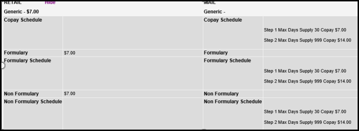

**Benefit Summary Screen (RxClaim)**

**Note:** If a plan (or client) has a multi-tier formulary, a message displays indicating this information. If not, then the Tier can only be inferred from Test Claim results; the actual Tier a medication falls under will only be indicated on the Rx Details Screen once a claim has been paid.

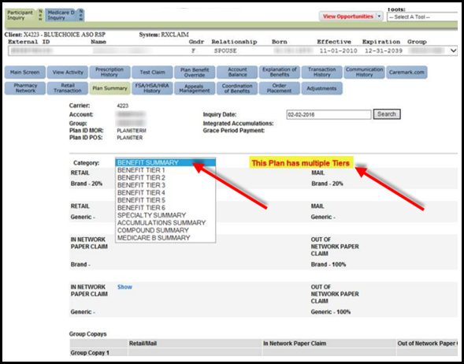

**Three Level Tiers**

|  |  |
| --- | --- |
| **Tier** | **Explanation** |
| **1 Preferred Generic** | Commonly prescribed generic drugs |
| **2 Preferred Brand** | Brand name drugs that don’t have a generic equivalent. They’re the lowest cost brand name drugs on the drug list |
| **3 Non-Preferred drug** | Higher priced brand name and generic drugs not in a preferred tier |

**Six Level Tiers**

|  |  |
| --- | --- |
| **Tier** | **Explanation** |
| **1 Preferred Generic** | Commonly prescribed generic drugs |
| **2 Generic** | Generic drugs, but they cost a little more than drugs in Tier 1 |
| **3 Preferred Brand** | Brand name drugs that don’t have a generic equivalent  Lowest cost brand name drugs on the drug list. |
| **4 Non-Preferred drug** | Higher priced brand name and generic drugs not in a preferred tier. |
| **5 Specialty** | Most expensive drugs on the drug list. Specialty drugs are used to treat complex conditions like Cancer and Multiple Sclerosis. They can be Generic or Brand name. |
| **6 Select Care** | Generic drugs used to treat diabetes and high cholesterol |

|  |  |
| --- | --- |
| **Field** | **Description** |
| **Brand** | Copay assigned to Brand medications |
| **Generic** | Copay assigned to Generic medications |
| **Standard/Brand** | Low copay, usually same as Preferred |
| **Formulary** | Copay for a Preferred drug from the formulary list |
| **Non-Formulary** | Copay for medications not on the formulary |
| **Brand/Formulary/Non-Formulary Copay Schedule** | How the copays are applied; for instance, one copay for every 30-day supply  **Example:** Based on Max Day Supply 999 (unlimited) apply a factor of 1.00 (one copay). If a Brand copay is $40, member copay would be $40. |
| **Grp Copay 1-8** | * Copays listed at the group level applies to RxClaim only * Copays fields 1-4 apply to Retail and fields 5-8 apply to Mail order * Refer to Benefits Notes to determine is the copay is flat or percentage |
| **Max Day** | Maximum day supply limitation allowed by the plan for claims payment |
| **Max Quantity** | * Maximum quantity limitation allowed by plan for claims payment * 9999 or blank indicates undefined, default to less than plan, not to exceed the day supply identified |
| **Maintenance- Max Quantity** | Limitations set by plan for medications identified as maintenance medications |
| **G or L** | Greater Than/Less than Indicator: If a Maximum Day supply and Maximum Quantity exist, this field indicates that the pharmacy can dispense whichever is greater (G) or lesser (L). |
| **Maintenance: G or L** | Same as above |
| **Refill limit** | Maximum number of refills payable by the insurance at a retail pharmacy per prescription before the member must use the PBM /Mail Order pharmacy |
| **Utilization** | Percentage of medication to be used before the plan will pay for refills |
| **DAW** | Applicable generic drug rules |
| **Non-Formulary Penalty** | Applicable Non-Formulary drug rules  **Note:** When referencing the Non-Formulary Penalty with your caller, use the term non-formulary surcharge. |
| **Rx Restrictions** | Maximum dollar amount for a prescription to pay on-line |
| **Retail 90 - Max Days** | Maximum day supply at Retail 90 network pharmacy |
| **Preferred Pharmacy Network** | Pharmacy Network which may offer a reduced cost share for the member |
| **Incentive Mail Maintenance Choice – Max Days** | Maximum day usage of mail order benefits |
| **Opt Out Type** | Maintenance Choice Opt Out availability and type |
| **Diabetic Kits** | Available diabetic bundling rules |

Top of the Document

|  |
| --- |
| Accumulations Summary |

This screen allows you to view general Deductible, Out of Pocket, Maximum Allowable Benefit, and Lifetime Benefit accumulation limit(s). If you need actual current accumulations, please see the Account Balance screen in PeopleSafe.

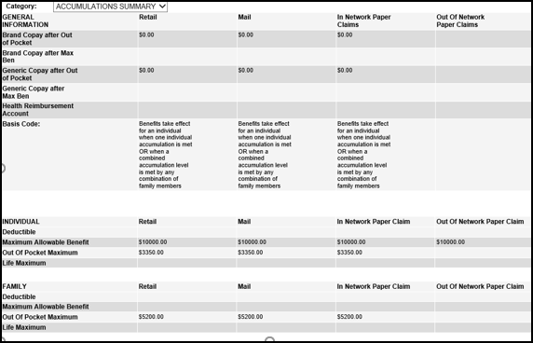

Top of the Document

|  |
| --- |
| Specialty Summary |

This screen contains a summary of the member’s Specialty prescription drug benefit plan. It displays the copay schedules for brand and generic specialty drugs filled at mail and retail.

Specialty medications are a diverse group of costly engineered drugs used to treat complex, chronic conditions. These medications often require special storage and handling and may not be readily available at the typical local retail pharmacy.

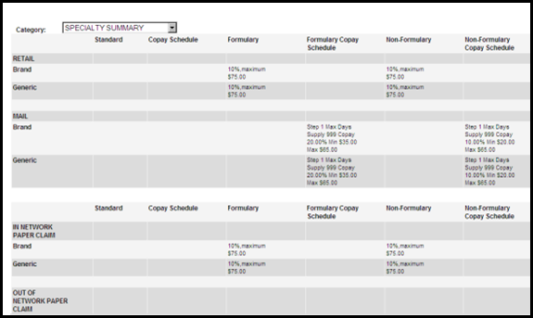

Top of the Document

|  |
| --- |
| Override Summary |

This screen displays what the plan permits for Vacation, Lost/Stolen Medication, and Therapy Change Submission Clarification Code (SCC) overrides. It displays the number of each override that is allowed, the number of overrides that have been used by the member and the applicable code is for each override. This code should be provided to the caller, and the pharmacy submits it when processing the claim.

* If an override section is blank, the override is not allowed by the client.
* If all override sections are blank, refer to the CIF and review available overrides.

**Note:** To view the previous year information, change the Inquiry date in the Search field to determine if the member was active during that period.

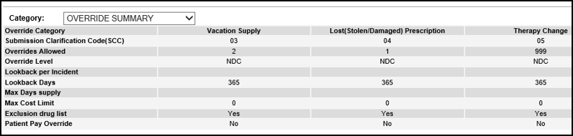

Top of the Document

|  |
| --- |
| Related Documents |

[Customer Care Abbreviations, Definitions and Terms Index (017428)](https://thesource.cvshealth.com/nuxeo/thesource/#!/view?docid=c1f1028b-e42c-4b4f-a4cf-cc0b42c91606) or [CarelonRx Customer Care Abbreviations, Definitions and Terms - Index (019003)](https://thesource.cvshealth.com/nuxeo/thesource/#!/view?docid=4d4bedc3-6ab8-46ce-8b90-f0b7bdabc984)

Top of the Document

Not to Be Reproduced or Disclosed to Others without Prior Written Approval

**ELECTRONIC DATA = OFFICIAL VERSION / PAPER COPY = INFORMATIONAL ONLY**